CS2318 / CS3339

Prof. Dan Tamir

Developing MIPS/SPIM programs

(From the book MIPS Assembly Language Programming by Britton)

Defining a static uninitialized array

Defining a static initialized array

Example of a MIPS program
Part1 – Pseudo code

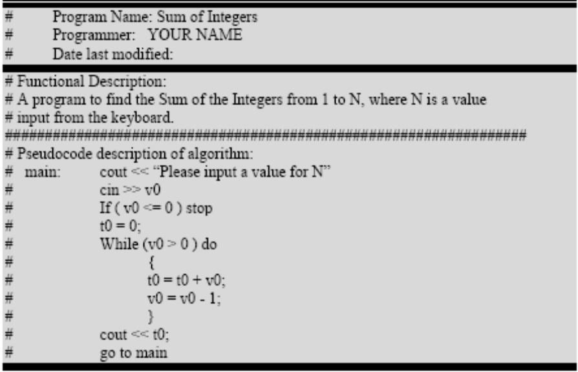

Example of a MIPS program (continued)
Part-2 MIPS program ready to run on SPIM

